Matt Isaac

Data Analysis Summary

Honors Contract Completion

3/17/2018

The survey that was given to students in the undergraduate statistics courses had a variety of items on it, including:

1. General descriptive items including age, class rank, major, current employment status
2. Questions about previous mathematics and statistics experience
3. Statements about mindset
4. Statements about the participant's attitudes towards statistics

Students were asked to respond with how much they agreed or disagreed with the statements about mindset (e.g. “You can always substantially change how much talent in statistics you have.”) and attitudes (e.g. “I have difficulty seeing how statistics relates to my field of study.”). The mindset statements and attitude statements were grouped into a total of four categories:

1. Mindset towards statistics
2. Mindset generally
3. Attitudes toward statistics (enjoyment/comfort with)
4. Attitudes toward statistics (perception of utility)

Because this Likert-Score data was designed to measure these four characteristics, composite scores were calculated for each of the above four categories. For the mindset scores, negative scores corresponded with negative mindsets, while positive scores corresponded with positive mindsets.

One of the most shocking results was the strong majority of growth mindsets in the class. See table and boxplots below:

|  |  |  |
| --- | --- | --- |
|  | Mindset | |
| Category | % Growth | % Fixed |
| Statistical Mindset | 95 | 5 |
| General Mindset | 94 | 6 |

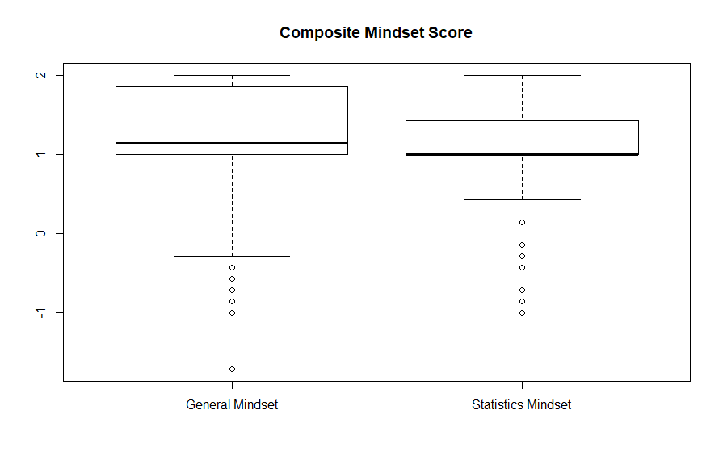

I performed inference to determine whether there was a significant difference in mean final course score between the growth and fixed mindset groups. A Wilcoxon Rank-Sum (non-parametric) test was used because the data did not meet the necessary assumptions for a parametric test.

For both the General Mindset category and the Statistics Mindset category, the test revealed that there is a significant difference between the final course scores of students in the growth mindset group and the fixed mindset group (p < 0.0001 for both tests).

Below is a graphical representation of the difference between grade distributions for the students with a growth mindset and a fixed mindset.

Although the tests came back significant statistically, there does not seem to be much of a difference in context of our data. The confidence intervals for the true location shift between the growth and fixed mindset groups for the General Mindset and Statistics Mindset groups respectively are ( 1.7, 2.1) and (1.4, 1.9 ). This means that the shifts between the growth and fixed mindset groups are between about 1.5 and 2 grade percentage points. From the view of a teacher, a difference of 2 percent in a grade is not particularly meaningful.

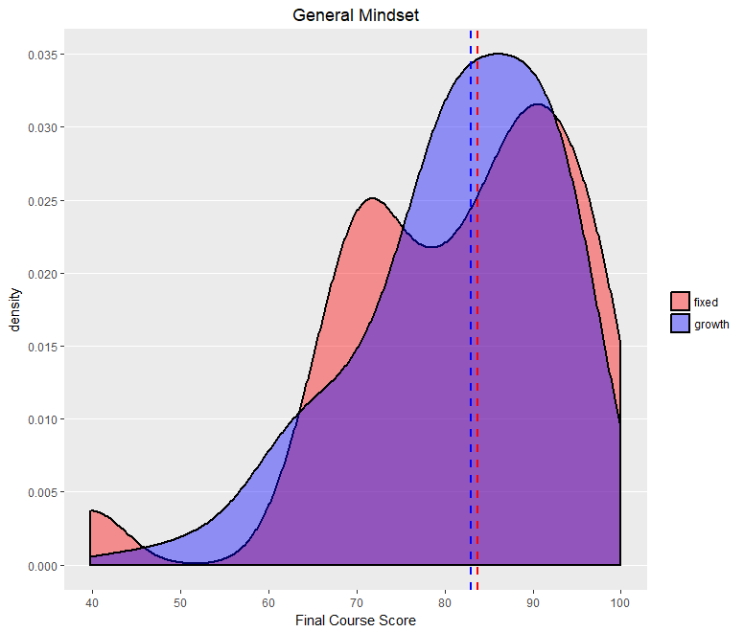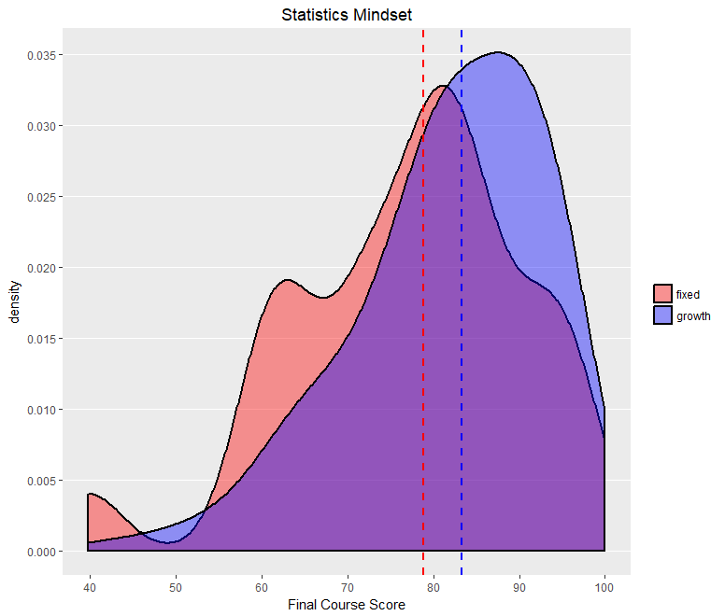

A similar analysis was performed for the Attitude scores.

|  |  |  |  |
| --- | --- | --- | --- |
|  | Attitude | | |
| Category | % Positive | % Negative | % Neutral |
| Enjoyment/Comfort | 64 | 30 | 6 |
| Perception of Utility | 84 | 12 | 4 |

A Kruskal-Wallis (non-parametric) test was performed to test for difference in mean final course score between the three attitude groups (positive, negative, and neutral) for both attitude categories. For both tests, a significant result was obtained (p < 0.0001). In other words, a significant difference in final course score between students with positive, negative, and neutral attitudes. Due to the construction of the Kruskal-Wallis test, and the fact that there are three groups being compared, we cannot obtain an estimate of location shift as we did for the tests on mindset. However, similar visualizations were created and are shown below.

Notably, the negative mindset groups have lower medians (represented by vertical dashed lines) than the other two groups. It is difficult to say whether the differences are significant in the context of grade percentages.

